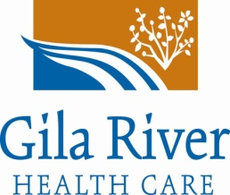
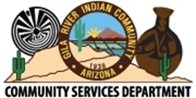
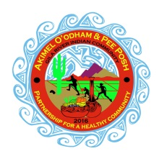
2016 Gila River Day of Hope
Presented by the Life Center
Funded through the GRIC Office of Special Funding and the Community Services Department

September 10, 2016
9:00 am to 4:00 pm
Sheraton Wild Horse Pass Conference Center

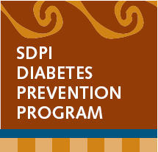
Booth Registration Form

Organization/Department Name: ______________________________________

Contact Name: _____________________________________________________

E-mail Address: _____________________________ Phone: _________________

Table needed: Yes ____ No____ (Note only 1 table per Dept.)

Can you donate a healthy item for our raffle? ____________________________

Name(s) of staff attending: ___________________________________________ (Please limit to 2 staff per Dept.)

**Set up will begin at 7:30am. Please have your booth set up by 8:30am.

Please email this form to:
Gila River Health Care Life Center
Attn: Natalyn Begay
Email to: nbegay@grhc.org
Call: (520) 562-1200 Ext. 7355

